Parents, welcome to Sparkhouse Online!
Sparkhouse Online makes it easy to stay connected to the lessons your children are learning each week in Sunday school. Follow the steps below to get started.

Getting Started
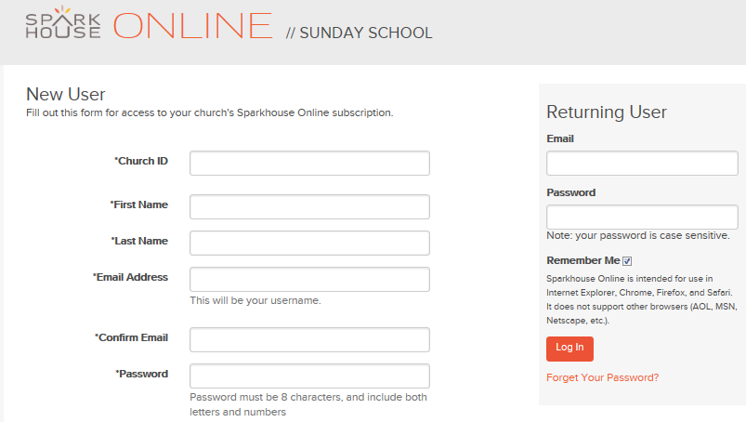Request access
- Go to Sparkhouse Online at http://sundayschool.sparkhouseonline.org.
- Under “New User,” enter your Church ID: [Communityinchrist]
- Complete the rest of the requested information and click “Submit.”
- You will receive a confirmation e-mail when
your request is approved.

Log in
- After you receive the confirmation e-mail, return to Sparkhouse Online.
- Enter your e-mail address and password under “Returning User.” Click “Log In.”

Edit your profile and add family members
- After you log in for the first time, click on your name in the upper right corner of the screen.
- On the form that displays next, update your profile information and change your password as needed. Click “Save” when you are done.
- To add a child to your profile, click “Add a Child Family Member,” near the bottom of the form. Complete the requested information and click “Save.”
- You can add an Adult Family Member to your profile, if you wish. Someone sending you a message through Sparkhouse Online has the option to copy your Adult Family Member(s).
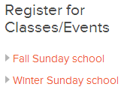
- Go to the Home page by clicking on “Sparkhouse Online Sunday School” at the top of the screen. Look at the “Register for Classes/Events” heading near the upper right corner of the screen. If there are no orange links under this heading, the Sunday school director now has all the information needed for your child’s registration.

If you see an orange link under “Register for Classes/Events”:*
- Click on the name of the classes or special event that applies to your child.
- On the next screen, click “Edit Registration” under “Register Family Members.”
- Check the box next to your child’s name and click “Register.”

*Note: Directors often use this optional feature when they need an exact head count for planning purposes, especially for purchasing supplies, getting drivers for a special event, etc.
Additional features you can use

Preview and download Family Pages for your child’s Sunday school lesson
- Once your child is assigned to a group (for example, Grade 1), you can view a list of your child’s upcoming classes and events. Go to the Home page by clicking on “Sparkhouse Online Sunday School” at the top of the page. Choose “My Family’s Classes & Events” from the dropdown list that appears when you click on the arrow or the orange text above the calendar. Use the arrows at the top of the calendar to go to another month.
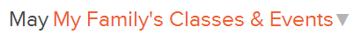
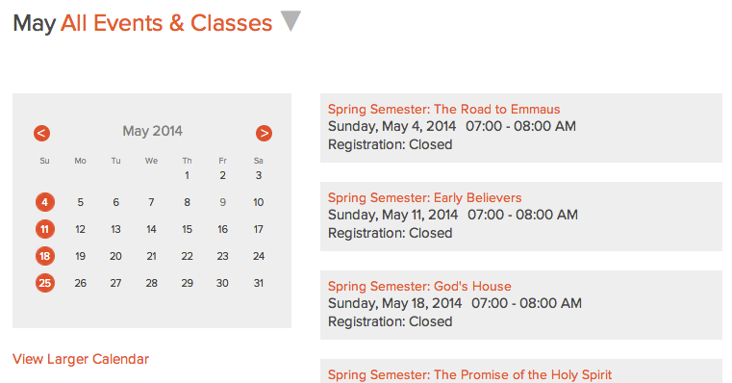

- Click on the name of a class or event.
- Preview and download the Family Pages for that class or event.

Send a message
- Go to the “Message Center” tab to send a message to the director, leaders, or other parents who are using your church’s Sparkhouse Online subscription.

